XD Toolkit Manual

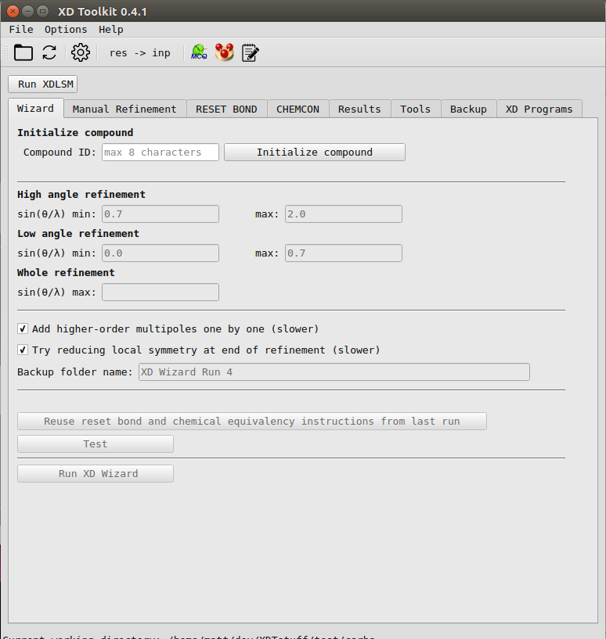

Contents

General | 3
Wizard | 4
Manual Refinement | 5
RESET BOND | 6
CHEMCON | 7
Results | 8
Tools | 9
Backup | 9
XD Programs | 9

General

Before you start a new refinement
1) In the folder that the SHELX structure solution was carried out, there should be a res and an hkl file.
2) Copy the res file to your project folder, and rename it “shelx.ins”.
3) Copy the hkl file to your project folder, and rename it “shelx.hkl”.
4) Alternatively, 2 and 3 can be done in XD Toolkit by clicking “File – Load Starting Files from Struture Solution Folder”. This will prompt you to first select your structure solution folder, and then your new project folder.

Atom label input format
Atom labels can be either comma or space separated.
e.g. ‘C(1), C(2), C(3)’ or ‘C(1) C(2) C(3)’
Labels are not case sensitive and brackets are not necessary.
e.g. “C(1)” = “c(1)” = “C1” = “c1”

Setting up external program paths
To use the XD programs, MoleCoolQt, Mercury and open the xd.mas file from XD Toolkit you may need to setup paths to these programs.
On Windows, XD Toolkit will automatically search for these paths so you may not need to set them up. However, if any of the paths cannot be found automatically, here are instructions to set the paths manually.
1) Click the settings icon in the toolbar, or go to Settings – Preferences.
2) To setup the XD programs click “Select XD location” and navigate to the folder where you have the XD programs. On Windows this is normally “C:/WinXD/bin”.
3) You may have to setup the XD_DATADIR environment variable. Instructions on setting environment variables can be easily found on google, and the path to set it to will be displayed by XD Toolkit if you do not have the environment variable already set.
4) To setup the other programs, click their respective “Select program buttons” and select the programs executable file.
Wizard
The Wizard tab takes some user input, and then goes through an entire standard refinement strategy from start to finish.
Guide
1) Type a name for your compound (max. 8 characters) in the “Compound ID” box, and click initialize compound.
NOTE: If you have a large structure this may take a short while, but shouldn’t take longer than a minute.
2) Enter your desired sin(θ/λ) cutoffs.
3) If you have H atoms in your structure, go to the “RESET BOND” tab. Click “Automatically add reset bond instructions”.
If the program says it cannot add reset bond instructions for any H atoms, go to the “Manually add reset bond instructions” section, and add an appropriate bond length for these atoms.
NOTE: Clicking the “Get other bond lengths” button in the “Manually add reset bond instructions” section will take you to a paper with tables of standard bond lengths from neutron diffraction.
4) Go to the “CHEMCON” tab. Leave “Automatically add chemical equivalency” checked and click “Add CHEMCON”.
5) Choose if you want to introduce higher-order multipoles one by one, and if you want to try lowering local symmetry at the end of the refinement, with the relevant check boxes in the wizard tab.
Both of these options are recommended, but doing them both makes the refinement strategy twice as long, so you may not wish to use one/both of them for larger structures.
6) Click “Test”. If everything is fine then you will get the message “Ready to run XD Wizard” folllowed by an estimated running time. Otherwise you will get instructions telling you what else you need to do.
7) Click “Run XD Wizard”.

Manual Refinement
This tab provides the ability to do everything that the wizard does, but with more button clicks.
Guide
1) Type a name for your compound (max. 8 characters) in the “Compound ID” box, and click initialize compound.
NOTE: If you have a large structure this may take a short while, but shouldn’t take longer than a minute.
2) Enter your desired sin(θ/λ) cutoffs or leave the boxes blank.
3) If there are instructions below the drop down menu of refinement types, follow them.
4) Click “Setup xd.mas”. If the program cannot setup anything, this will be displayed.
5) Make any desired additional changes to xd.mas.
6) Click “Run XDLSM” near the top left of the window.
7) Once XDLSM has finished running click the “Show results” button to view the output of the refinement.
8) Use the default backup name or choose your own and click “Save backup”.
9) Click the “res→inp” button in the toolbar.
10) Repeat steps 2-9 for every refinement type in the drop down menu.

RESET BOND
Automatically add reset bond instructions:
This will automatically detect H atoms in the listed environments and add reset bond instructions with the bond lengths displayed to xd.mas.
If any H atoms are found for which the program cannot recognise the environment, their names will be displayed below the “Automatically add reset bond instructions” button.

Manually add reset bond instructions:
All H atom labels entered will be set to the bond length entered.
If the “All” box is checked, all H atoms will be set to the bond length entered.
Tables of standard bond lengths can be found by clicking “Get other bond lengths”.
Formatting:
- It is not necessary to write “H” in the atom label.
- i.e. “H(1)” = “1”

Disable/enable reset bond instructions:
This leaves the reset bond instructions in xd.mas, but comments them out, or uncomments them.

Delete all reset bond instructions:
Removes all reset bond instructions from xd.mas.

CHEMCON
Automatically add chemical equivalency:
This will automatically find chemically equivalent atoms and make them chemically equivalent in the CHEMCON column of xd.mas.
It works by finding all the possible paths through the structure, starting from every atom. If two atoms have exactly the same paths through the structure they are defined as chemically equivalent.

Other options:
The other two options are there to aid in defining custom chemical equivalency, however unless you have your own reasons for adding custom chemical equivalency, the automatic option is recommended.

Results
Get current LSM output
Displays basic results from the file xd_lsm.out in the current project folder.

Get LSM output from backup
“Show results of one refinement backup”:
Shows basic results from the file xd_lsm.out in the selected folder.
“Show summary of entire backup folder”:
If a folder is selected with subfolders each containing an xd_lsm.out file, results from each subfolder will be displayed in a summary table (exactly the same as the Wizard displays).

Make residual density maps
“Produce map around atom nearest largest residual peak”:
Runs XDFFT to find largest residual peak, and then produces residual density map around the atom that is closest to the residual peak.
“Produce map around given atom”:
Produces residual density map around inputted atom.
“Produce map from current xd_fou.grd file”:
This option will show produce a residual density map from the xd_fou.grd file that is in the current project folder.

Make normal probability plot
Runs XDFOUR with instructions to make a 3D xd_fou.grd file for the whole unit cell, then produces a normal probability plot from this file.

Get d-orbital populations
Runs XDPROP with instructions to calculate d-orbital populations and displays the results.

Tools
Add local coordinate system
Adds a local coordinate system to the atom table in xd.mas with the input given, and selects multipole parameters to be refined in the key table based on the inputted local symmetry.

Add dummy atom
Adds a dummy atom to xd.mas in the average position of the two inputted atoms.
i.e. Atom 1 position = (0, 0, 0)
Atom 2 position = (1, 1, 1)
Dummy position = (0.5, 0.5, 0.5)

Add multipoles to key table
Adds multipole parameters to be refined in the key table, based on the local symmetry written in the SITESYM column of the atom table.

Backup
Load backup
Loads files from selected folder into the current project folder, overwriting files in the current project folder.
Backup files
Backs up the files xd.mas, xd.res, xd.inp and xd_lsm.out to the folder name given. This folder is located in a folder named “Backup” in the current project folder.

XD Programs
From here you can run the XD programs. They will take instructions from whatever files are in the current project folder, and output result files there as well.

